Missing Output Controller

Typically, when the rip's launched, the Navigator and the Output Controller window are started. If the Output Controller window is NOT present and is also not an option from the Output menu, this would indicate the RIP or Raster Blaster configuration has the page buffering selection set to 'Single (If required).'

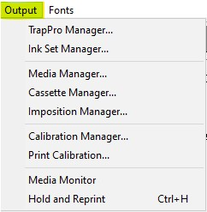

In a Raster Blaster Pro, this selection is correct. However, a standard Navigator Rip (with or without a workflow), the page buffer setting needs to be changed to ‘Multiple (Parallel).'

From the Navigator pull-down menu, select Configure Rip.

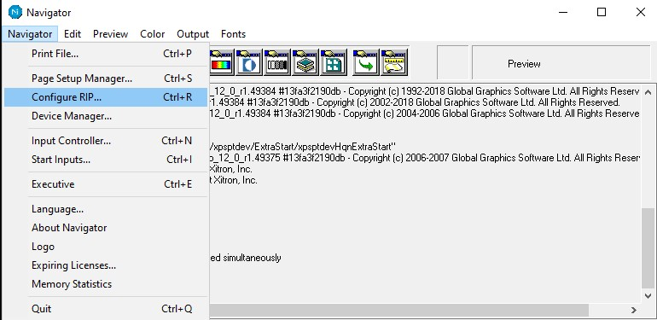

When the configure rip window opens, select ‘Multiple (Parallel)’ from the Page buffer options.

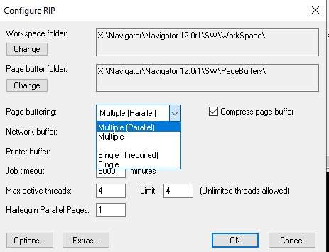

Click ‘Ok.’

Once ‘Multiple (Parallel)’ has been selected, the Output Controller/Monitor window should be visible.

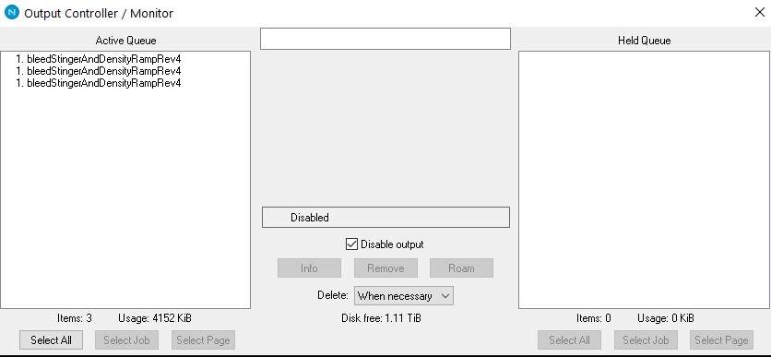

If the Output Controller window is still not seen, you may have to open this window by selecting
‘Output Controller’ from the Output pull-down menu as shown here:

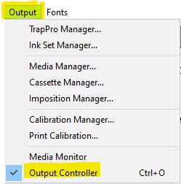

The Output Controller window should then be operational.

If you see the Output Controller option from the pull-down menu, but the Output Controller window is still not visible, please review the ‘Missing Window’ tech note.

