Attaching Any Harlequin OEM rip to Xitron Navigator Server
Adjust the UAC settings on the computer where the workflow is to be installed. To do this, click once on the main WINDOWS ICON in the taskbar, which expands the WINDOWS ICON. Start typing UAC and hit the 'Enter' key. The User Account Control Settings window opens, as shown below.
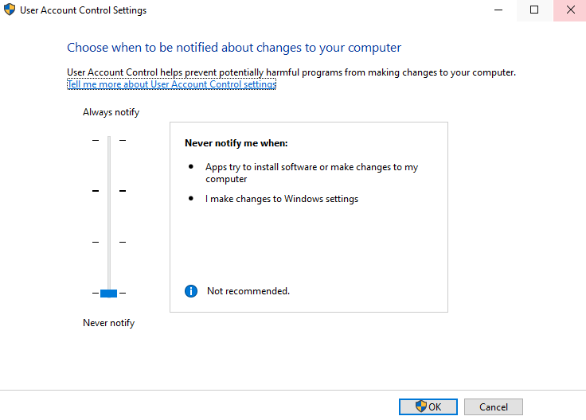
Adjust the slider to 'Never notify'], then apply the change.
Step 1: Install rip as you usually would. If you want the Harlequin rip to be in the same folder structure as the Navigator Server, install the Navigator Server first and inside the C:\Navigator folder make an enclosing folder for the Harlequin rip and install it there.
Step 2: License and configure the rip, including Page Setups, Page Features, Separation styles, Color Pro setups, calibrations, etc. Because input jobs go through the Navigator Server, we would recommend that you not add any Spool Folders, Socket input to NT Pipe setups to the rip.
Step 3: Our Navigator Server requires a Page setup called Default Page Setup. The settings must match the screenshot shown below:

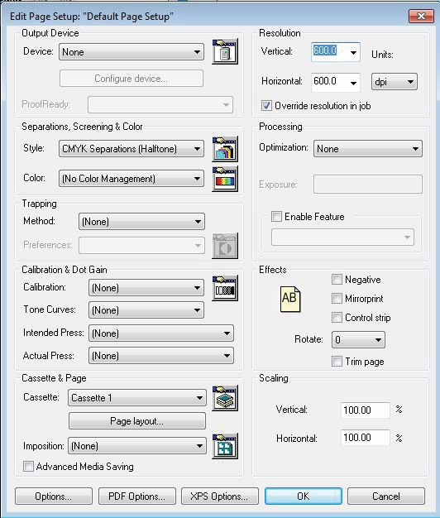

Step 4: If the Harlequin rip is already installed, you can then install the Navigator Server. You may accept the default folder for the Navigator Server. When the Navigator Installation DVD asks you what you want to install, Select Rip and/or Workflow Server. See below.

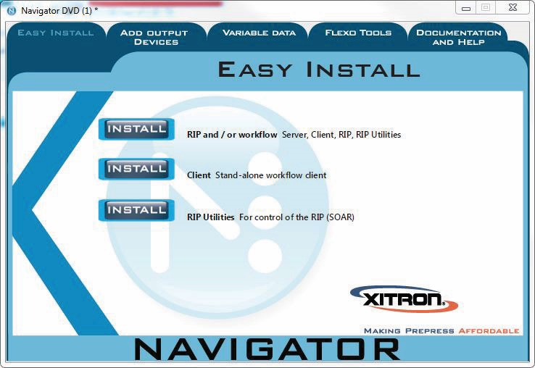

Step 5: Select Install Server only, see below:

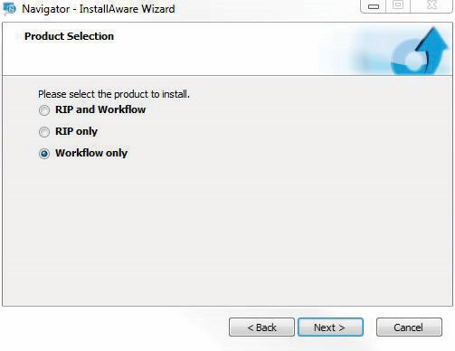

Step 6: Select holding software for the Navigator Server - default is ok to use, see below:
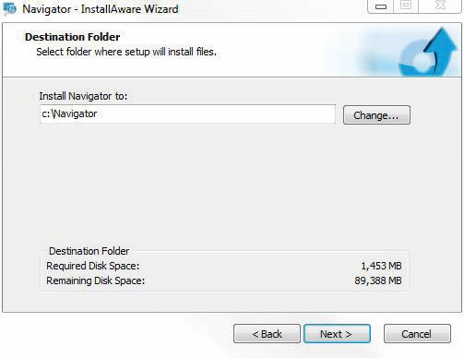

Step 7: Install Rip Manager Utilities to the Harlequin rip. To do this, relaunch the installer from the Navigator DVD and select Rip Utilities, see below:

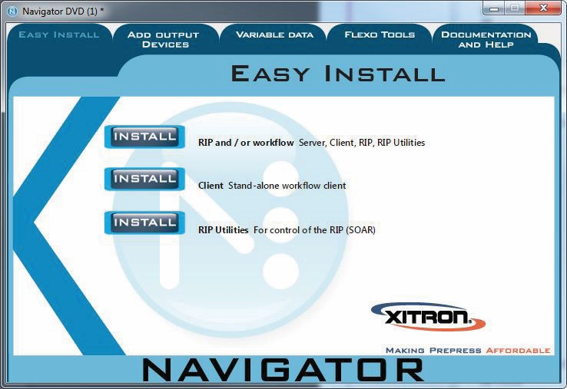

Step 8: Select "Change" and browse to the folder where the rips installed. NOT the SW folder, but the folder where the rip .exe is installed.
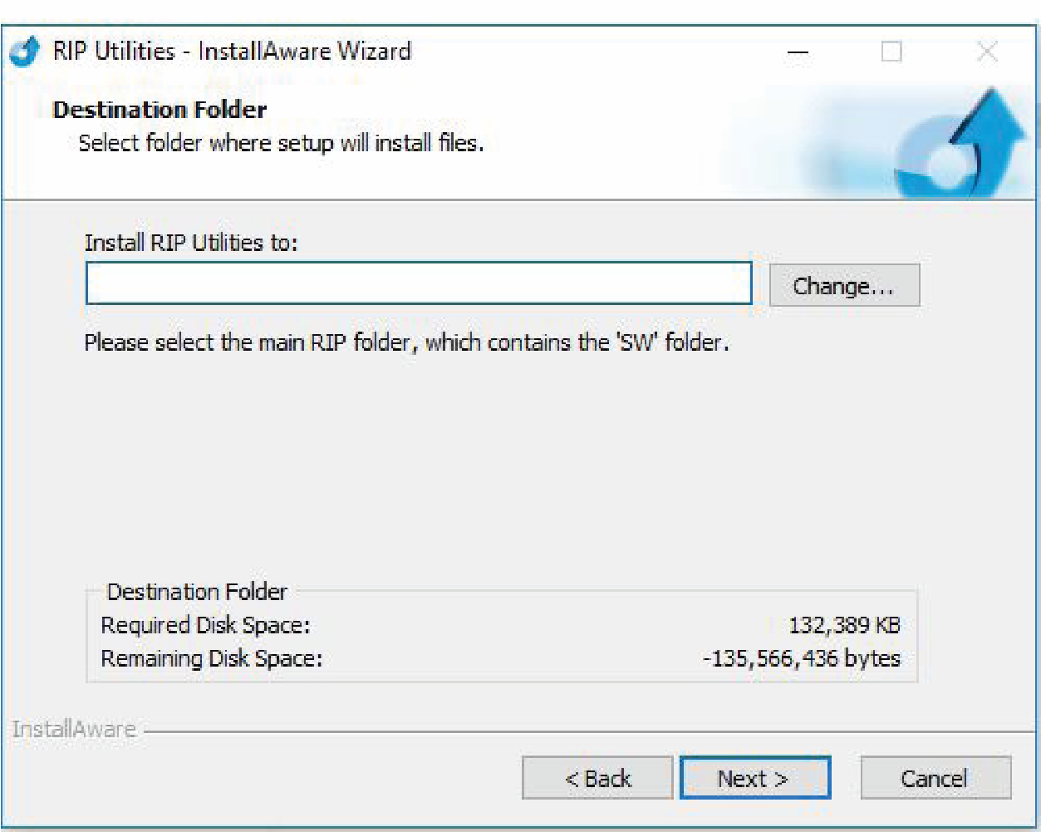

Step 9: Download the Exile rip SOAR Dropbox package from the below Dropbox link:

https://www.dropbox.com/s/hgavc7d39airae4/Exile%20rip%20SOAR%20Dropbox%20package.zip?dl=0

Step 10: From the zip file, extract the folder called Multi rip utility
Step 11: Inside the Multi rip folder utility double-click the MultiRIP.hta utility
Step 12: Under the top rip configuration setup (Rip Instance 0) click browse. See below.
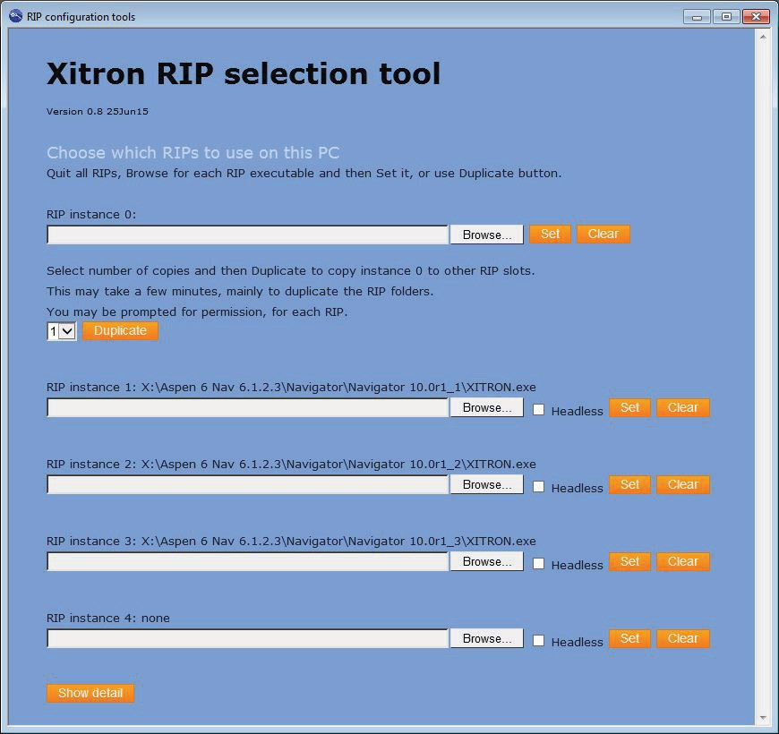

Step 13: Browse to the rip .exe folder and select the .exe file itself. See below.

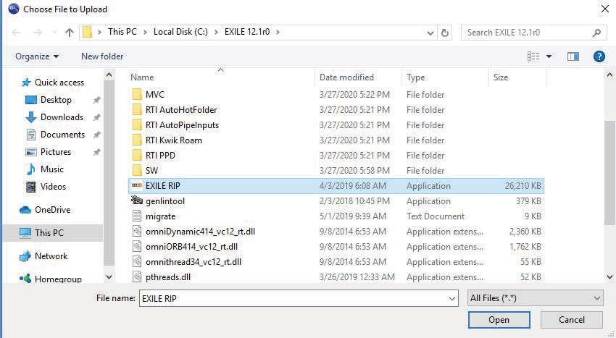

Step 14: Hit “Set” to write this rip into SOAR’s registry as rip instance 0. See below:
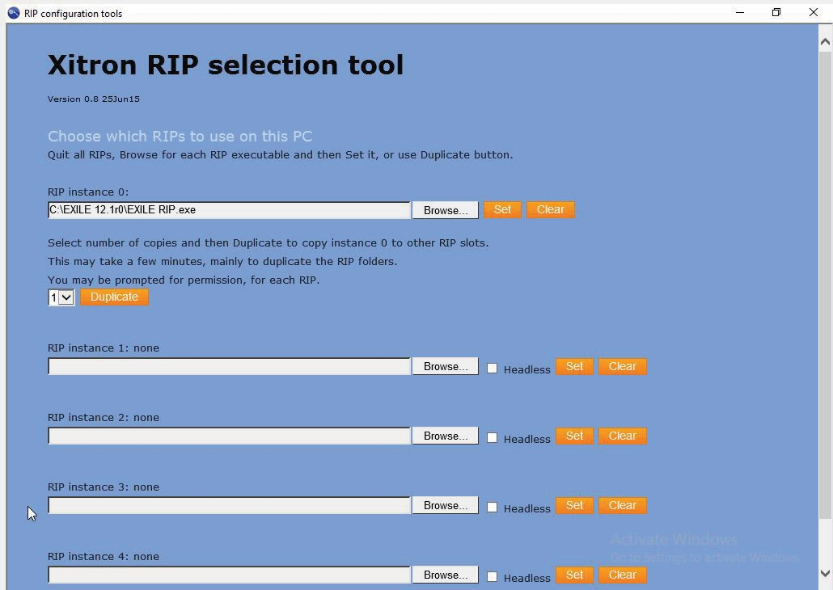
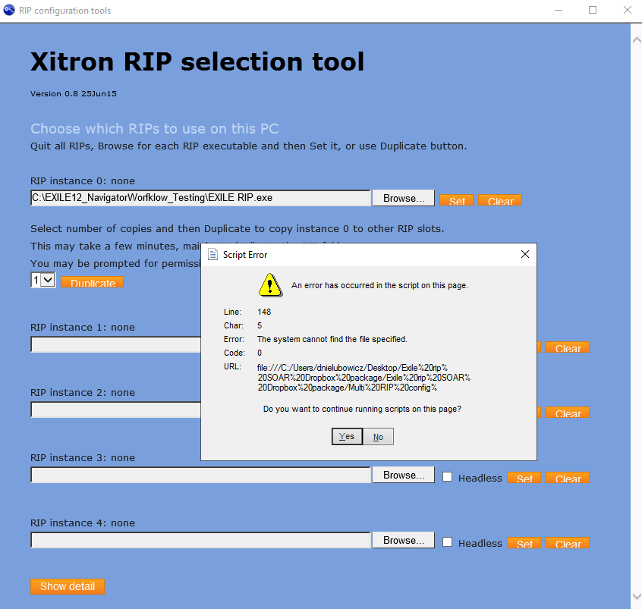
If your rip is version 10 or older, it should be ready to use at this point. Start the Navigator server and then verify the rip starts. You see some prompts where the Server and SOAR are asking permission to use your networks. Grant any requested access. Then, shut down the server and verify that the rip also shuts down. Once done, you are ready to configure your Navigator Server. If your rip is version 11 or 12, there are a few more steps we have to take to get this going. See below.
Step 15: In the zip file you downloaded, extract the folder called Files and place it in the rip folder. In there, you'll find three files:
omniDynamic414_vc12_rt.dll,
omniORB414_vc12_rt.dll,
omnithread34_vc12_rt.dll

Copy these files into the main rip folder, alongside the rip's .exe file. When done, the rip's main folder should look like the following screenshot
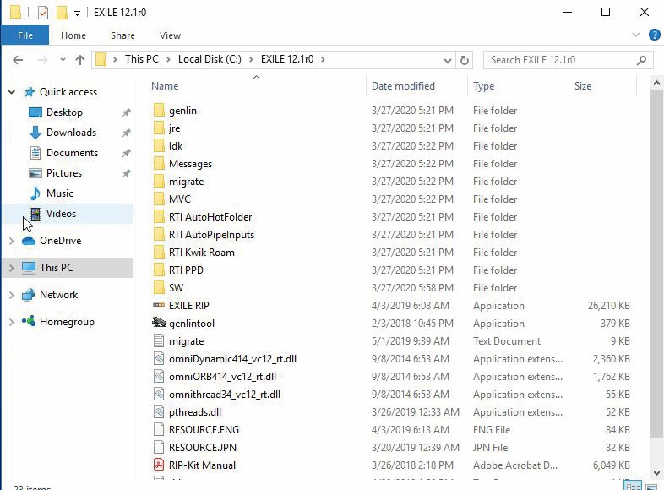

Step 16: Go back to the zip file you downloaded and extract the folder called SOARNX
Place this folder in the \rip folder\SW\Extensions\PS Devices. See below screenshot for correct location:
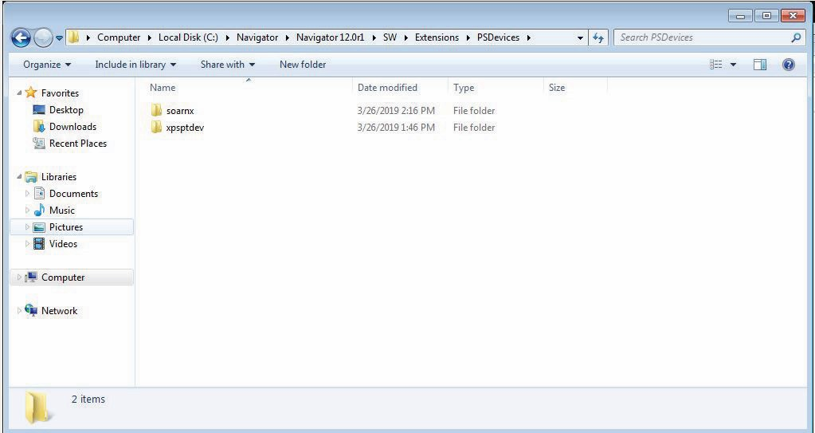

Step 17: From the zip file you downloaded, extract the folder File needed for SW-SYS-ExtraStart.
In this folder, you'll find a file called soarnxHqnExtraStart. Take this file and place it in the \rip folder\SW\SYS\ExtraStart folder. See below for how it should look:
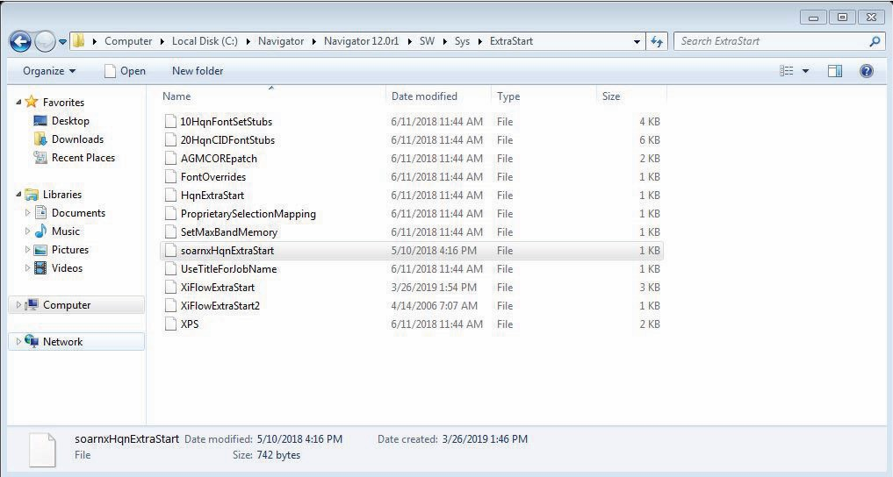

Your rip should be ready to use at this point. Start the Navigator server and then verify the rip starts. You'll see some prompts where the Server and SOAR are asking permission to use your networks. Grant any requested access. Then, shut down the server and verify that the rip also shuts down. The rip and server are now connected, and you're ready to configure the Navigator Server for your production needs.

